**Cloudera Hadoop installed on Google compute instance using docker image**



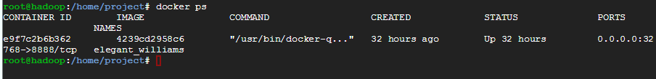

**Output of map reduce job:**

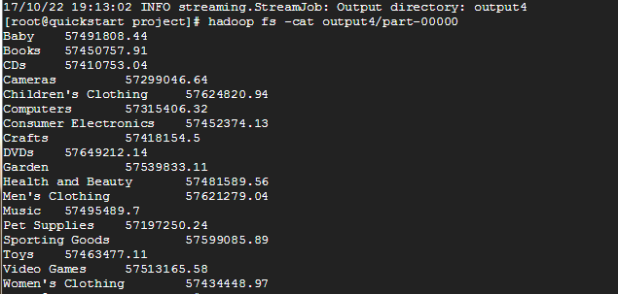

**Hadoop file system output:**

